Appendix

A1 – Physical-hygric characterization

This appendix reports supplementary material related to the physical-hygric characterisation of the two investigated clay-based materials and moisture buffering performance of the flat and 3D-printed components.

Mineralogical characterisation of clay and clay-lime performed by X-ray diffraction (XRD)

The X-ray diffraction (XRD) patterns of the investigated clay and clay–lime samples are reported in Figure C1.1 These results are derived from the experimental campaign presented in V. Gentile et al. [37] and are provided here to document the mineralogical nature of the materials analysed in section 2.1 “Material formulation”.

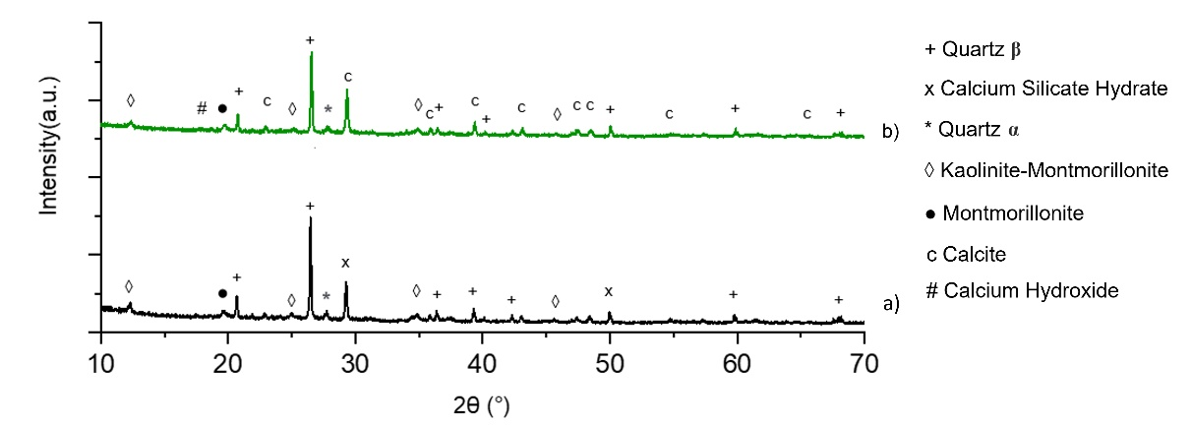
Figure A1.1: Results of XRD measurements for (a – black line) clay and (b- green line) clay-lime (clay with 20% of Ca(OH)₂).
Flat and 3D-printed samples

A summary of the samples used in the MBV test is reported in Table A1.1 including dry mass, bulk density, dimensions, shrinkage and exposed surface area. The latter refers to the total surface available for moisture exchange with the surrounding air. For flat samples, it was calculated considering the exposed top surface, while for 3D-printed samples it was calculated from the digital model in Rhinoceros, accounting for the increased exchange area generated by the printing pattern (excluding the bottom and lateral areas, as they are sealed during the MBV test).

Table A1.1 Summary of samples used in the MBV test. Values for flat samples are reported as mean ± standard deviation (no. of samples= 3), while values for 3D-printed samples refer to a single specimen (n = 1).
 |  | Clay | Clay-lime
Flat sample
Dry mass (m₀) | [g] | 869± 49 | 633 ± 35
Thickness (t) | [cm] | 4.6 ± 0.3 | 4.5 ± 0.1
Surface extension (A) | [cm²] | (10.4 ± 0.4) x (10.6 ± 0.3) | (9.9 ± 0.4) x (10.5 ± 0.1)
Exposed surface (A _{exp}) | [cm²] | 106.1 ± 7.7 | 103.9 ± 3.8
Dry bulk density (ρ₀) | [kg/m³] | 1781±27 | 1328±31
3D-printed sample
Dry mass (m₀) | [g] | 911 | 614
Thickness (t) | [cm] | 4.5 | 4.3
Surface extension (A) | [cm²] | 12.7 x 12.7 | 12.4 x 12.4
Exposed surface (A _{exp}) | [cm²] | 3702 | 3430
Dry bulk density (ρ₀) | [kg/m³] | 1260 | 930
Shrinkage [37] | [%] | xy plane 14.1 - z axis 6.3 | xy plane 18.1 - z axis 10.4

A2 – MBV measurements – Boundary conditions

This section presents the temperature and relative humidity profiles recorded during the MBV tests conducted at Polito and ETHz.

Figure A2.1: Temperature and relative humidity conditions imposed during MBV test in the Polito climatic chamber.

Figure A2.3: Temperature and relative humidity conditions imposed during MBV test in the ETHz climatic chamber for (a) clay samples and (b) clay-lime samples.

A3 – Numerical investigation

This appendix reports supplementary material related to the input data for WUFI Pro simulation at material and component scale of the two investigated clay-based materials.

Table A3.1 Input data for WUFI Pro simulations at material scale.
Property | Unit | Clay | Clay-lime
Thickness (t) | [mm] | 45 | 43
Dry density (ρ₀) | [kg/m³] | 1781 | 1328
Open porosity (ε) | [%] | 33.69 | 45.33
Specific heat capacity (C_{p}) | [J/kgK] | 1000 | 1000
Thermal conductivity (λ) | [W/mK] | 0.59 | 0.59
Water vapour diffusion resistance factor (µ) | [-] | 21.67 | 8.98
Water absorption coefficient (A_{W}) | [kg/ m²√s] | 0.38 | 0.36
Reference water content – w90 | [kg/m³] | 55.98 | 36.26
Free water saturation | [kg/m³] | 337 | 453
Open porosity (P_{o}) | [%] | 33.69 | 45.33
Sorption isotherm | [kg/m³] | Adsorption  u(0) = 0.00  u(0.33) = 13.96  u(0.53) = 21.38  u(0.73) = 32.95  u(0.83) = 43.77  u(0.90) = 55.98 | Adsorption  u(0) = 0.00  u(0.33) = 9.64  u(0.53) = 13.65  u(0.73) = 21.25  u(0.83) = 27.68  u(0.90) = 36.26

Table A3.2 Input data for WUFI Pro simulations at component scale of 3D-printed components for both adopted approaches.
Property | Unit | 3D Clay |  | 3D Clay-lime
Property | Unit | EPOA | EFVMA | EPOA | EFVMA
Thickness (t) | [mm] | 1.4 | 45 | 1.3 | 43
Dry density (ρ₀) | [kg/m³] | 1781 | 1255 | 1328 | 928
Open porosity (ε) | [%] | 33.69 |  | 45.33
Specific heat capacity (C_{p}) | [J/kgK] | 1000 |  | 1000
Thermal conductivity (λ) | [W/mK] | 0.59 |  | 0.59
Water vapour diffusion resistance factor (µ) | [-] | 21.67 | 14 | 8.98 | 10
Water absorption coefficient (A_{W}) | [kg/ m²√s] | 0.38 |  | 0.36
Reference water content – w90 | [kg/m³] | 55.98 |  | 36.26
Free water saturation | [kg/m³] | 337 |  | 453
Open porosity (ε) | [%] | 33.69 |  | 45.33
Sorption isotherm | [kg/m³] | Adsorption  u(0) = 0.00 ± 0.00  u(0.33) = 13.96 ± 0.24  u(0.53) = 21.38 ± 0.47  u(0.73) = 32.95 ± 0.55  u(0.83) = 43.77 ± 1.02  u(0.90) = 55.98 ± 1.56 |  | Adsorption  u(0) = 0.00 ± 0.00  u(0.33) = 9.64 ± 0.16  u(0.53) = 13.65 ± 0.27  u(0.73) = 21.25 ± 0.43  u(0.83) = 27.68 ± 0.43  u(0.90) = 36.26 ± 0.16

